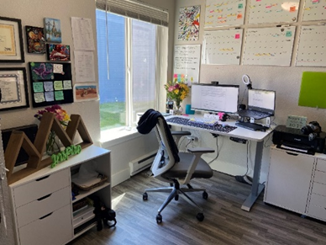

In my office, there is a desk in the corner, next to the window. In front of it, I have an ergonomic chair. On the desk, I have two monitors placed on a white stand and a keyboard below the monitors. I also have some flowers next to the monitors. Above the desk, I have a series of whiteboards and calendars on the wall, along with some colorful sticky notes.

To the right of the desk, I have a white cabinet with a printer on it. Behind the desk, there is another white cabinet. On top of it, I have some decorative objects and a plant. Above this cabinet, there are several framed certificates on the wall.